Case 7-AM,S-Peru-Moche-Mask-Jaguar Theriomorph-Copper-900 CE

Moche Copper Shaman Mask for auction at no reserve. This ancient copper artifact was made by the Moche Culture of Coastal Peru. This copper mask is in the form of a Shaman or Warrior. He has fangs coming from his mouth and facial tattoos and scarification. It has large ear spools, the bottom of the right one was repaired. This ancient artifact has heavy oxidation and dents.

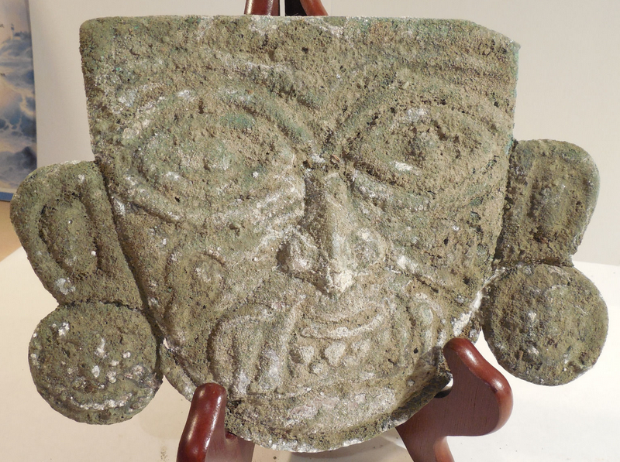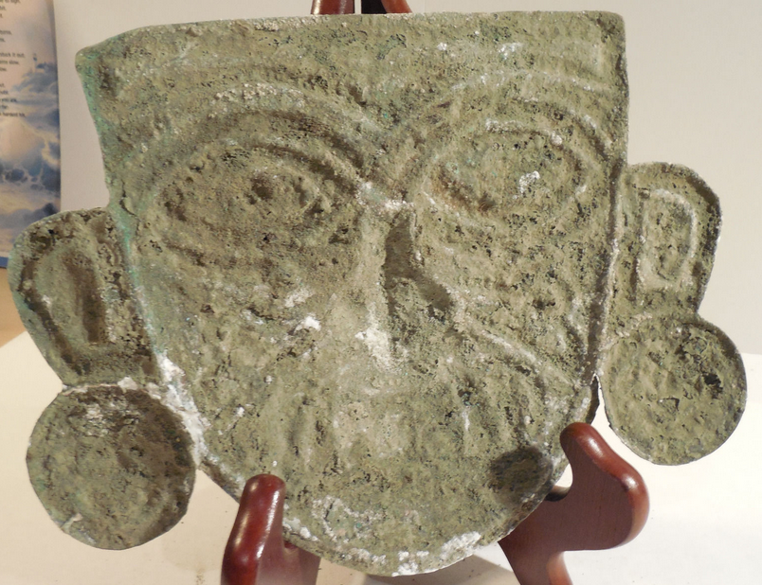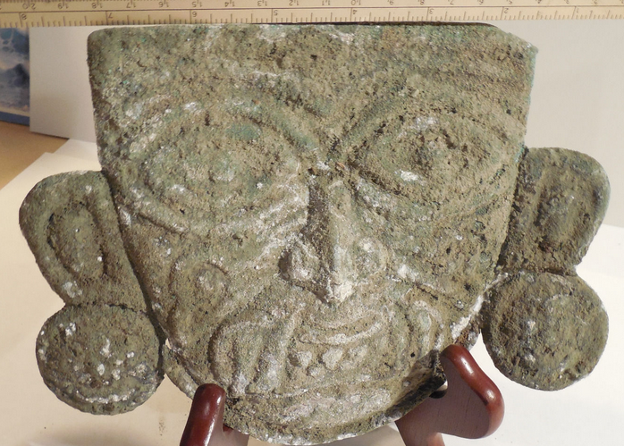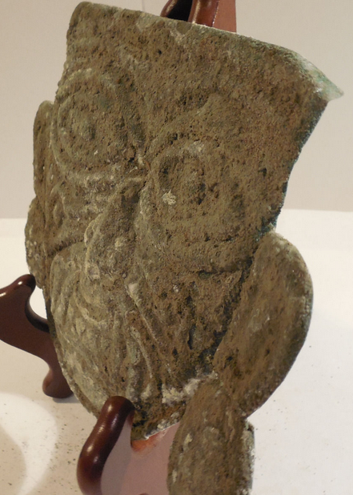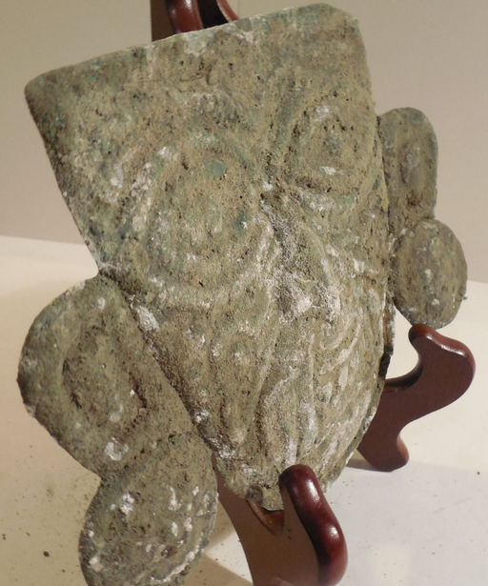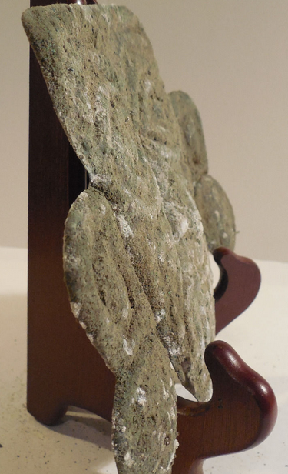

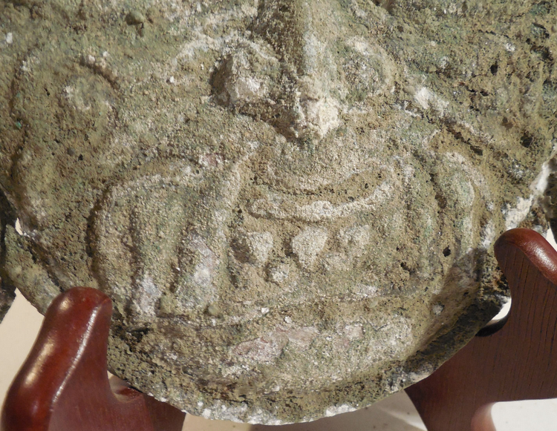

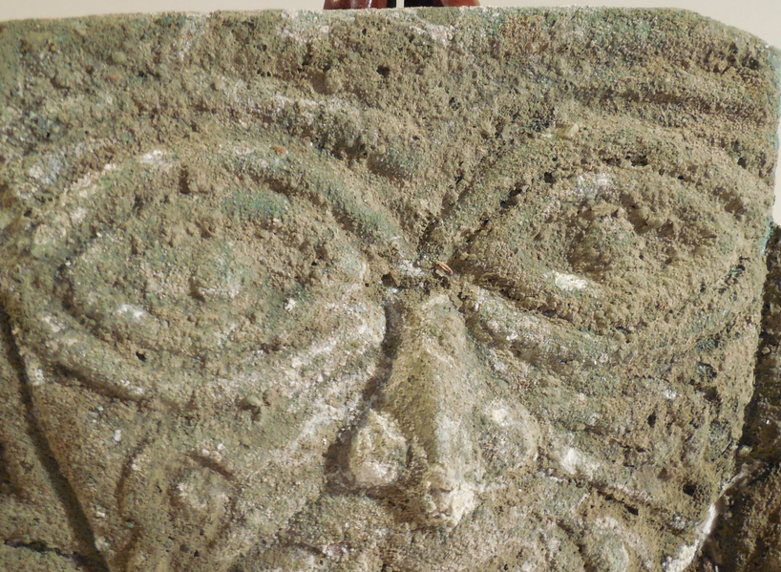

**Order details**

**Sales order**

Sold by [**ancientgas**](http://myworld.ebay.com/ancientgas) ( [992](http://feedback.ebay.com/ws/eBayISAPI.dll?ViewFeedback&userid=ancientgas) )

**Delivery package 1 of 1**

Estimated delivery **Wednesday, Dec 30, 2015** **- Monday, Jan 4, 2016**

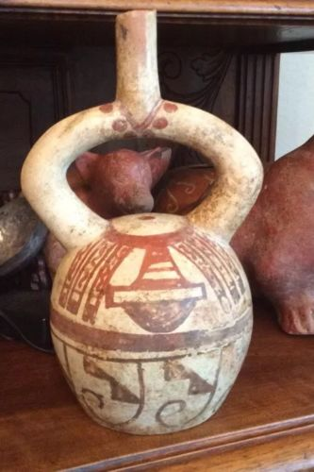

[**Moche IV Blow Bottle 400-600AD Weapon Bundle And Wave + Step Motif**](http://www.ebay.com/itm/221952944734)

|  |  |
| --- | --- |
| Item price | $400.00 |
| Quantity | 1 |
| Item number | 221952944734 |
| Shipping service | USPS Priority Mail Large Flat Rate Box |

**Sales order**

Sold by [**bobski117**](http://myworld.ebay.com/bobski117) ( [2807](http://feedback.ebay.com/ws/eBayISAPI.dll?ViewFeedback&userid=bobski117) )

**Delivery package 1 of 1**

Estimated delivery **Tuesday, Dec 29, 2015** **- Saturday, Jan 2, 2016**

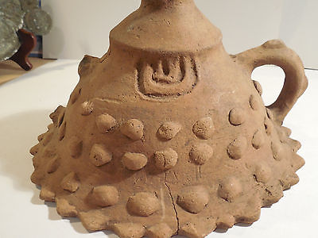

[**Colima Large Incense Lid Shaft Tomb Pre-Columbian Archaic Ancient Artifact Mayan**](http://www.ebay.com/itm/191762068598)

|  |  |
| --- | --- |
| Item price | $34.01 |
| Quantity | 1 |
| Item number | 191762068598 |
| Shipping service | USPS Priority Mail |

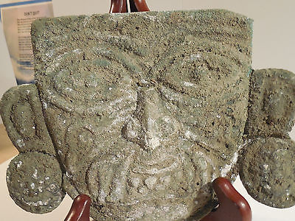

[**Moche Copper Shaman Mask Pre-Columbian Archaic Ancient Artifact Chimu Inca Mayan**](http://www.ebay.com/itm/121843120911)

|  |  |
| --- | --- |
| Item price | $520.00 |
| Quantity | 1 |
| Item number | 121843120911 |
| Shipping service | USPS Priority Mail |